Preparation for the 3rd International Conference on Business Management and Innovation Abstract Paper: Year 2027

^{[1]} Alexander Clay, ^{[2]}*Mahmood Abbas, ^{[3]} Siham Hamidin

^{[1]} allex@usa.edu.my, ^{[2 ]}Mahmood@iiu.edu.my, ^{[3]} Siham_h@oum.edu.my
^{[1,2,3]} Department of Business and Management, Universiti Massucite, London
*Corresponding Author

ABSTRACT

Authors’ full names are preferred in the author section of the manuscript. The abstract should provide a concise yet thorough summary of the article, serving as a comprehensive reflection of its content. It must be self-contained and should not include abbreviations, footnotes, or references. The abstract should represent a condensed version of the entire article, effectively encapsulating the key points not exceed of 150 words. Adhering to this word limit is crucial, as exceeding it will necessitate revisions. The abstract should be written as a single paragraph, and it must not include any displayed mathematical equations or tabular data. Additionally, it should incorporate three to four distinct keywords or phrases to enhance the discoverability of the article. Care should be taken to avoid excessive repetition of these keywords, as this may lead to rejection by search engines. Finally, ensure that the abstract is clear, well-structured, and grammatically sound for ease of readability and comprehension.

Keywords: Decision Making, Priorities Analytic Hierarchy Process, AHP.

Citation :
Received :
Accepted :
Published :

1.0 INTRODUCTION

This formatting guideline is specifically designed for papers intended for publication in the ICBIV 2025 conference proceedings. Do not change the headers and page numbers format. Authors are encouraged to consult the official conference website to obtain the most up-to-date information on formatting requirements. All manuscripts must be written in English and should not exceed 10,000 words, inclusive of diagrams, figures, tables, and other relevant content. Follow the font size as stated in this template (different section such as the topic, authors name and affiliations, abstract, topic of the section have different size and format). For this section, the text should be typed in Arial font, size 10, with single spacing to maintain a clean and professional appearance. Do not fill up the section of “Citation, Received, Accepted, and Published”. The first paragraph of the section should align with the left margin, without any indentation. For all new paragraphs that follow, apply a single tab to create a clear distinction between paragraphs, ensuring consistency and readability throughout the document.

1.1. BACKGROUND

Abbreviations and acronyms should be defined upon their first appearance in the text, even if they have already been defined in the abstract. Common abbreviations such as SI, ac, and dc do not require definition. Abbreviations that include periods should be written without spaces (e.g., "C.N.R.S.," not "C. N. R. S."). Avoid using abbreviations in the title unless absolutely necessary, such as when including "ETC" in the title of this article.

1.2. ABBREVIATIONS AND ACRONYMS

Use a single space following periods and colons. Hyphenate complex modifiers, such as "zero-field-cooled magnetization." Avoid dangling participles, for example, instead of writing "Using (1), the potential was calculated," which lacks clarity, write "The potential was calculated by using (1)" or "Using (1), we calculated the potential."
Always place a zero before decimal points, e.g., "0.25" rather than ".25." Use "cm³" instead of "cc" to denote cubic centimeters, and express dimensions as "0.1 cm × 0.2 cm" rather than "0.1 × 0.2 cm²." The proper abbreviation for "seconds" is "s," not "sec." When expressing units such as webers per square meter, use "Wb/m²" or write out "webers per square meter," rather than "webers/m²." For value ranges, use "7 to 9" or "7–9," but avoid using the tilde symbol, as in "7∼9."
A parenthetical statement at the end of a sentence should be punctuated outside the closing parenthesis (as in this example). However, if the entire sentence is within parentheses, the punctuation remains inside the parentheses. In American English, periods and commas are placed inside quotation marks, e.g., "like this." Other punctuation, such as exclamation points, remains outside, e.g., "like this"! Avoid contractions; for example, use "do not" instead of "don’t." The serial comma is preferred, as in "A, B, and C," rather than "A, B and C."
First-person singular or plural, as well as the active voice, is acceptable, such as "I observed that..." or "We observed that..." rather than the passive "It was observed that...". Ensure accurate spelling, and if English is not your first language, have your manuscript carefully proofread by a native English-speaking colleague. Limit the variety of typefaces used in a single article to maintain professionalism and readability. Excessive use of typefaces can detract from scholarly writing. Additionally, MathJax may not support unconventional fonts, so avoid using them where possible.

2.0 LITERATURE REVIEW

Number equations consecutively, placing the equation numbers in parentheses aligned with the right margin, as demonstrated in (1). To streamline equations, consider using the solidus (/), the exponential function (exp), or exponents where appropriate. Always use parentheses to prevent ambiguities in denominators. Equations should be punctuated when they are part of a sentence, as shown:

E = mc². (1)

Ensure that all symbols within the equation are defined either before the equation is presented or immediately afterward. Symbols should be italicized (e.g., *T* may denote temperature, while **T** refers to the unit tesla). When referencing equations within the text, use “(1)” rather than “Eq. (1)” or “equation (1),” except when beginning a sentence, in which case the proper format is: “Equation (1) is... .”

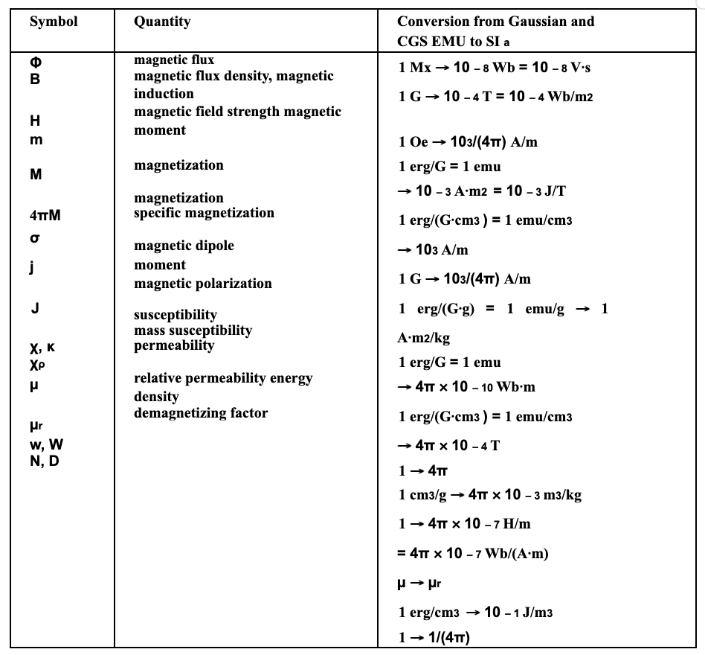
Table 1: Saaty’s Pairwise Comparison Scale (Saaty, 2012)

All tables and figures should be submitted exclusively in image formats, such as JPG or PNG, to ensure compatibility and ease of display. Each figure or table must be centrally aligned within the text to maintain a clear and professional layout. The corresponding figure or table number, along with a concise title, should be placed directly below the figure or table. This format ensures clarity and proper association of the figure or table with its explanatory caption, enhancing the overall presentation of the content.

3.0 CONCLUSION

A conclusion section is optional and not mandatory. While it may serve to summarize the key points discussed in the paper, avoid simply repeating the content of the abstract. Instead, the conclusion should provide additional insights, such as emphasizing the significance of the work, discussing potential applications, or suggesting directions for future research and extensions of the study. This approach allows the conclusion to contribute meaningfully to the overall paper, offering a broader perspective beyond a mere restatement of findings.

4.0 ACKNOWMEDGEMENT

Acknowledgments and details of funding sources should be listed at the end of the title page. For compliance with funding requirements, present funding information as follows:

This work was supported by the Department of Social Welfare [grant numbers 1234, 4567]; the Selangor Heritage Foundation, Shah Alam [grant number 1234]; and Khazanah Nasional Berhad [grant number 1234].

If no specific funding was received, include the following statement:

"This research did not receive any specific grant from public, commercial, or not-for-profit funding agencies."

In American English, the preferred spelling of "acknowledgment" omits the "e" after the "g." Always use the singular heading "Acknowledgment," even if you are acknowledging multiple individuals or institutions. Avoid using informal expressions such as "One of us (S.B.A.) would like to thank ... ." Instead, adopt a more formal approach, such as "F. A. Author thanks ... ."

5.0 REFERENCE

A complete reference entry must provide sufficient details to allow the reader to locate the cited article, whether in print or electronic form. If you are uncertain about the correct abbreviation of a specific journal's title, it is preferable to write the full title to avoid ambiguity. The use of Latin terms such as *loc. cit.* and *ibid.* should be avoided in citations.
For this conference paper, employ the APA (American Psychological Association) referencing style, which follows an author-date format. This citation style is widely used in disciplines such as psychology, sociology, anthropology, education, and other fields within the social sciences. In APA style, in-text citations include the author's last name and the year of publication, while the full reference details are provided in a reference list at the end of the paper. This format ensures that your references are clear, precise, and accessible to readers, maintaining a consistent scholarly standard across your writing. For more information, please visit: http://www.apastyle.org/index.aspx. An example of a citation in APA format is as follows:

- For books:
Author, A. A. (Year). *Title of work: Capital letter also for subtitle*. Publisher.

- For journal articles:
Author, A. A., Author, B. B., & Author, C. C. (Year). Title of article. *Title of Periodical*, *volume number*(issue number), pages. https://doi.org/xx.xxx/yyyy

- Other examples:
Gan, L. Y., Khan, M. T. I., & Liew, T. W. (2021). Understanding consumer’s adoption of financial robo‐advisors at the outbreak of the COVID‐19 crisis in Malaysia. Financial Planning Review, 4(3), 1–18. https://doi.org/10.1002/cfp2.112
Gerlach, J. M., & Lutz, J. K. T. (2019). Evidence on usage behavior and future adoption intention of FinTechs and digital finance solutions. The International Journal of Business and Finance Research, 13(2), 83–105.
Hair, J. F., Matthews, L. M., Matthews, R. L., & Sarstedt, M. (2017). PLS-SEM or CB-SEM: Updated guidelines on which method to use. International Journal of Multivariate Data Analysis, 1(2), 107–123.
Hoe, J. K. (2023). Adoption of robo-advisory service in the personal financial planning industry in Australia. 8th International Conference on Financial Innovation and Economic Development (ICFIED 2023), 632–638.
Khoo, C. C., Ong, S. F., & Liew, C. Y. (2024). Factors which affect investors’ intention to adopt robo-advisory services in Malaysia. 2nd International Conference on Automotive, Manufacturing, and Mechanical Engineering, 1–10. https://doi.org/10.1063/5.0182740
Kwon, D., Jeong, P., & Chung, D. (2022). An empirical study of factors influencing the intention to use robo-advisors. Journal of Information and Knowledge Management, 21(3), 1–24. https://doi.org/10.1142/S0219649222500393
Mohta, A., & Shunmugasundaram, V. (2024). Moderating role of millennials’ financial literacy on the relationship between risk tolerance and risky investment behavior: Evidence from India. International Journal of Social Economics, 51(3), 422–440. https://doi.org/10.1108/IJSE-12-2022-0812
Nguyen, T. P. L., Chew, L. W., Muthaiyah, S., Teh, B. H., & Ong, T. S. (2023). Factors influencing acceptance of robo-advisors for wealth management in Malaysia. Cogent Engineering, 10(1), 1–13. https://doi.org/10.1080/23311916.2023.2188992
Nourallah, M. (2023). One size does not fit all: Young retail investors’ initial trust in financial robo-advisors. Journal of Business Research, 256, 113470. https://doi.org/10.1016/j.jbusres.2022.113470
Ramayah, T., Cheah, J., Chuah, F., Ting, H., & Memon, M. A. (2018). Partial Least Squares Structural Equation Model (PLS-SEM) using SmartPLS 3.0 (1st Editio). Pearson.
Ramesh, K. P., Amudha, R., Prasob, K. C., & Francis, J. (2023). Robo-advisory an intrinsic convergence of AI in enhancing investment returns - An empirical analysis. Multidisciplinary Science Journal, 5, 1–5. https://doi.org/https://doi.org/10.31893/multiscience.2023ss0321

